**ASSIGNMENT-5**

**1.** **Given two sorted arrays nums1 and nums2 of size m and n respectively, return the median**

**of the two sorted arrays.**

**The overall run time complexity should be O(log (m+n)).**

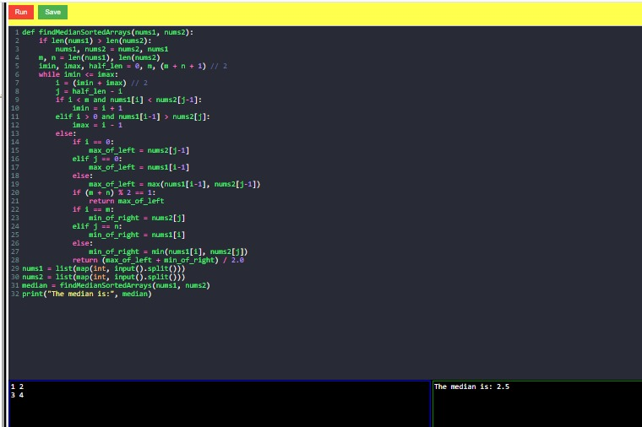

**2.** **Given two integers dividend and divisor, divide two integers without using multiplication,**

**division, and mod operator.**

**The integer division should truncate toward zero, which means losing its fractional part. For**

**example, 8.345 would be truncated to 8, and -2.7335 would be truncated to -2.**

**Return the quotient after dividing dividend by divisor.**

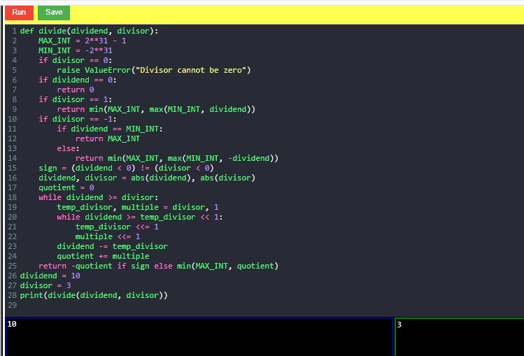

**3.** **Given the root of a binary tree, imagine yourself standing on the right side of it, return the**

**values of the nodes you can see ordered from top to bottom.**

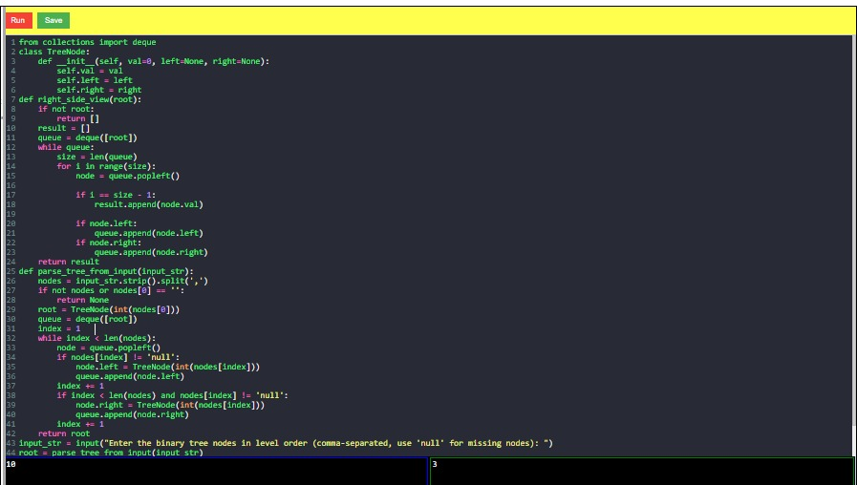

**4.** **Given an integer array nums, move all 0's to the end of it while maintaining the relative order**

**of the non-zero elements.**

**Note that you must do this in-place without making a copy of the array.**

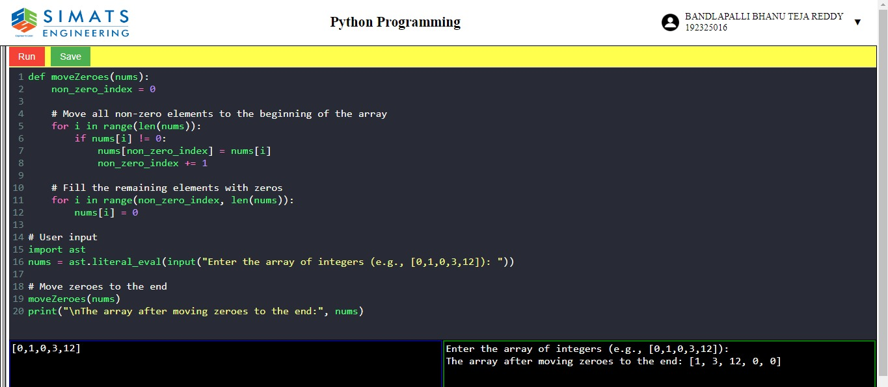

**5.** **Given a positive integer num, return true if num is a perfect square or false otherwise.**

**A perfect square is an integer that is the square of an integer. In other words, it is the product of**

**some integer with itself.**

**You must not use any built-in library function, such as sqrt.**

